**Subject: Software Construction and Development (Practical)**

**(Lab 2 - Tasks Solution)**



|  |  |
| --- | --- |
| **Roll No** | **22SW040** |
| **Section** | **One** |
| **Name** | **Farooque Sajjad** |
| **Teacher** | **Ma’am Hina** |

**LAB 02 TASKS (Use case diagram)**

**NOTE: THE DIAGRAMS ARE CREATED WITH A WEB APP NAMED Lucid chart (An online platform)**

**Task 1**

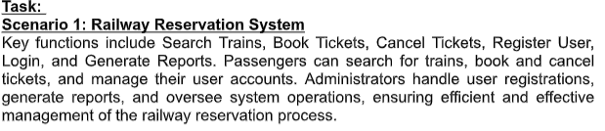

TASK 02

